DBMS Assignment 2
ER Diagram Design and Relational Schema
Application / Domain: Online Food Delivery System

This document builds on the tables identified in DBMS Assignment 1 (Online Food Delivery System) and develops them into a complete Entity–Relationship (ER) model and a normalized relational schema. All eight entities from Assignment 1 — Customer, Address, Restaurant, Menu_Item, Delivery_Partner, Orders, Order_Item and Payment — are retained, so the ER model matches the application scope selected earlier.

1. Entities and Attributes
Each entity below lists its attributes, data types, and its Primary Key (PK). Foreign Keys (FK), where present, are shown in purple and are explained fully in Section 4.

1.1 Customer
Attribute | Data Type | Key | Description
Customer_ID | INT | PK | Unique identifier for each customer
Name | VARCHAR(100) |  | Full name of the customer
Email | VARCHAR(150) | UNIQUE | Login email address
Phone | VARCHAR(15) | UNIQUE | Primary contact number
Password | VARCHAR(255) |  | Hashed account password

1.2 Address
Attribute | Data Type | Key | Description
Address_ID | INT | PK | Unique identifier for each saved address
Customer_ID | INT | FK | Owning customer (references Customer)
House_No | VARCHAR(30) |  | House / flat / apartment number
Street | VARCHAR(150) |  | Street name
City | VARCHAR(100) |  | City name
Pincode | VARCHAR(10) |  | Postal code

1.3 Restaurant
Attribute | Data Type | Key | Description
Restaurant_ID | INT | PK | Unique identifier for each restaurant
Restaurant_Name | VARCHAR(150) |  | Name of the restaurant
Phone | VARCHAR(15) |  | Restaurant contact number
Address | VARCHAR(255) |  | Physical location of the restaurant
Rating | DECIMAL(2,1) |  | Average customer rating

1.4 Menu_Item
Attribute | Data Type | Key | Description
Item_ID | INT | PK | Unique identifier for each menu item
Restaurant_ID | INT | FK | Restaurant offering the item (references Restaurant)
Item_Name | VARCHAR(150) |  | Name of the food item
Description | VARCHAR(500) |  | Brief description of the item
Price | DECIMAL(10,2) |  | Current unit price
Availability | BOOLEAN |  | Whether the item is currently orderable

1.5 Delivery_Partner
Attribute | Data Type | Key | Description
Delivery_ID | INT | PK | Unique identifier for each delivery partner
Name | VARCHAR(100) |  | Full name of the delivery partner
Phone | VARCHAR(15) | UNIQUE | Contact number
Vehicle_Number | VARCHAR(20) | UNIQUE | Registered vehicle number
Status | VARCHAR(30) |  | Current availability, e.g. Available / On Delivery

1.6 Orders
Attribute | Data Type | Key | Description
Order_ID | INT | PK | Unique identifier for each order
Customer_ID | INT | FK | Customer who placed the order (references Customer)
Restaurant_ID | INT | FK | Restaurant fulfilling the order (references Restaurant)
Address_ID | INT | FK | Delivery address for the order (references Address)
Delivery_ID | INT | FK | Delivery partner assigned (references Delivery_Partner)
Order_Date | DATETIME |  | Timestamp when the order was placed
Order_Status | VARCHAR(30) |  | e.g. Placed, Preparing, Out for Delivery, Delivered, Cancelled
Total_Amount | DECIMAL(10,2) |  | Total value of the order

1.7 Order_Item (associative entity)
Attribute | Data Type | Key | Description
Order_ID | INT | PK, FK | References Orders
Item_ID | INT | PK, FK | References Menu_Item
Quantity | INT |  | Number of units of the item ordered
Unit_Price | DECIMAL(10,2) |  | Price of the item at the time of ordering

1.8 Payment
Attribute | Data Type | Key | Description
Payment_ID | INT | PK | Unique identifier for each payment record
Order_ID | INT | FK, UNIQUE | Order being paid for (references Orders)
Payment_Method | VARCHAR(30) |  | e.g. UPI, Card, Cash on Delivery
Payment_Status | VARCHAR(30) |  | e.g. Pending, Successful, Failed, Refunded
Payment_Date | DATETIME |  | Timestamp the payment was completed
Amount | DECIMAL(10,2) |  | Amount charged

2. Relationships and Cardinalities
Entity A | Entity B | Cardinality | Description
Customer | Address | 1 : N | A customer may save many delivery addresses; each address belongs to one customer.
Customer | Orders | 1 : N | A customer may place many orders; each order is placed by exactly one customer.
Restaurant | Menu_Item | 1 : N | A restaurant offers many menu items; each menu item belongs to one restaurant.
Restaurant | Orders | 1 : N | A restaurant fulfils many orders; each order is placed at one restaurant.
Delivery_Partner | Orders | 1 : N | A delivery partner delivers many orders over time; each order is assigned to one delivery partner.
Address | Orders | 1 : N | A saved address can be used for many orders; each order ships to exactly one address.
Orders | Menu_Item | M : N | An order can contain many menu items, and a menu item can appear in many orders. Resolved by Order_Item.
Orders | Payment | 1 : 1 | Each order has exactly one payment record, and each payment record belongs to exactly one order.

3. ER Diagram
The diagram below shows all eight entities, their attributes, primary keys (PK, bold), foreign keys (FK, purple) and the cardinality of every relationship (1, N).
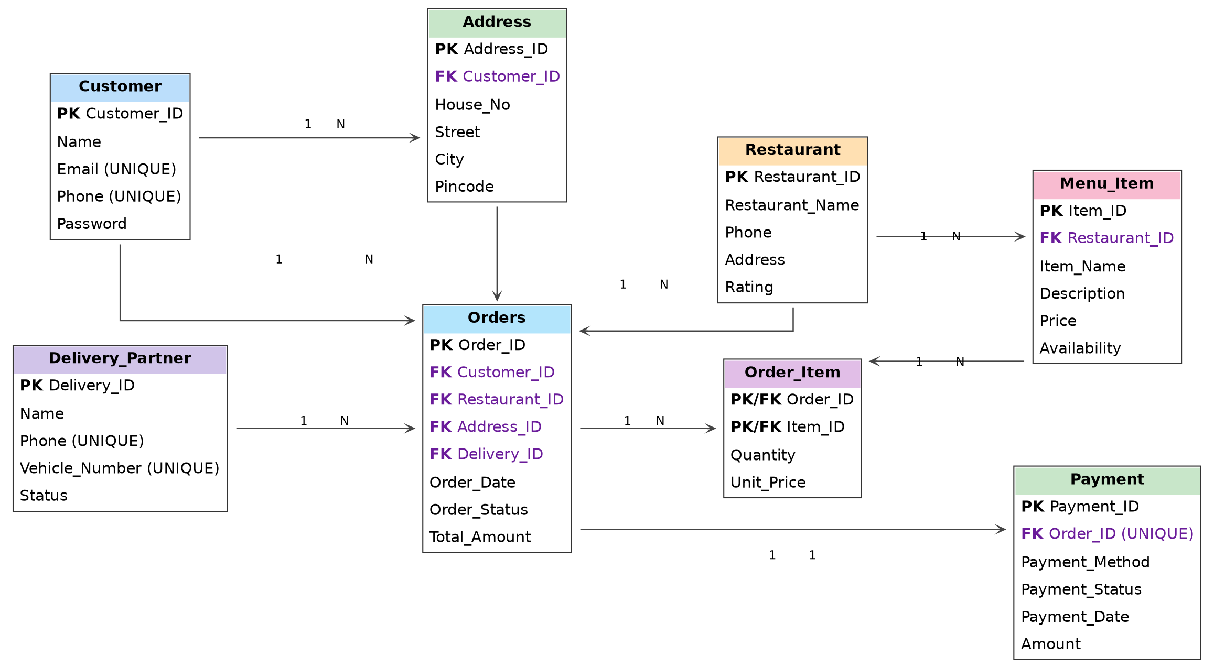

4. Relational Schema
The ER diagram converts directly into the following relations. Primary keys are underlined in bold; foreign keys are shown in purple with their referenced table.

CUSTOMER (Customer_ID PK, Name, Email, Phone, Password)
ADDRESS (Address_ID PK, Customer_ID FK → CUSTOMER.Customer_ID, House_No, Street, City, Pincode)
RESTAURANT (Restaurant_ID PK, Restaurant_Name, Phone, Address, Rating)
MENU_ITEM (Item_ID PK, Restaurant_ID FK → RESTAURANT.Restaurant_ID, Item_Name, Description, Price, Availability)
DELIVERY_PARTNER (Delivery_ID PK, Name, Phone, Vehicle_Number, Status)
ORDERS (Order_ID PK, Customer_ID FK → CUSTOMER, Restaurant_ID FK → RESTAURANT, Address_ID FK → ADDRESS, Delivery_ID FK → DELIVERY_PARTNER, Order_Date, Order_Status, Total_Amount)
ORDER_ITEM (Order_ID PK, FK → ORDERS, Item_ID PK, FK → MENU_ITEM, Quantity, Unit_Price)
PAYMENT (Payment_ID PK, Order_ID FK, UNIQUE → ORDERS.Order_ID, Payment_Method, Payment_Status, Payment_Date, Amount)
A complete, executable MySQL script implementing this schema (CREATE DATABASE and all eight CREATE TABLE statements with constraints) is provided as the accompanying file online_food_delivery_schema.sql.

5. Primary Key and Foreign Key Identification
Table | Primary Key | Foreign Key(s)
Customer | Customer_ID | —
Address | Address_ID | Customer_ID → Customer.Customer_ID
Restaurant | Restaurant_ID | —
Menu_Item | Item_ID | Restaurant_ID → Restaurant.Restaurant_ID
Delivery_Partner | Delivery_ID | —
Orders | Order_ID | Customer_ID → Customer.Customer_ID; Restaurant_ID → Restaurant.Restaurant_ID; Address_ID → Address.Address_ID; Delivery_ID → Delivery_Partner.Delivery_ID
Order_Item | Order_ID, Item_ID (composite) | Order_ID → Orders.Order_ID; Item_ID → Menu_Item.Item_ID
Payment | Payment_ID | Order_ID → Orders.Order_ID (UNIQUE, enforces 1:1)

6. Relationship Explanation
- Customer – Address (1:N): Each customer can save multiple delivery addresses (home, work, etc.), but every address record belongs to exactly one customer.
- Customer – Orders (1:N): A customer can place many orders over time; each individual order is tied to exactly one customer.
- Restaurant – Menu_Item (1:N): A restaurant maintains a catalog of many menu items; each menu item is offered by exactly one restaurant.
- Restaurant – Orders (1:N): A restaurant fulfils many orders; each order is placed with exactly one restaurant.
- Delivery_Partner – Orders (1:N): A delivery partner can be assigned to and fulfil many orders over time; each order is handled by at most one delivery partner.
- Address – Orders (1:N): A saved address may be reused as the delivery location for several orders; each order specifies exactly one delivery address.
- Orders – Menu_Item (M:N, via Order_Item): One order can include several different menu items, and the same menu item can appear across many different orders. This many-to-many relationship cannot be represented directly in a relational table, so it is resolved with the Order_Item associative table, whose composite primary key (Order_ID, Item_ID) uniquely identifies each line item and also stores Quantity and the Unit_Price locked in at order time.
- Orders – Payment (1:1): Every order generates exactly one payment record, and every payment record is tied to exactly one order. This is enforced by making Payment.Order_ID both a foreign key and UNIQUE.

Design note: Payment.Order_ID carries a UNIQUE constraint to enforce the 1:1 relationship. If the application later needs to support split payments or multiple payment attempts per order, that constraint can be relaxed to a plain foreign key, changing the relationship to 1:N.

7. Final Submission Checklist
- Entities and attributes identified for all 8 tables from Assignment 1.
- Primary keys identified for every entity.
- All relationships and their cardinalities (1:1, 1:N, M:N) documented.
- Digital, clearly labelled ER diagram included (Section 3).
- Relational schema matches the ER diagram exactly (Section 4).
- Foreign keys identified for every table, including the Order_Item associative table resolving the Orders–Menu_Item M:N relationship (Section 5).
- Executable MySQL script (online_food_delivery_schema.sql) provided alongside this document.

